Create Company (Transaction Code OX15):

Path: **SAP Customising Implementation Guide>Enterprise Structure>Definition>Financial Accounting> Define Company**

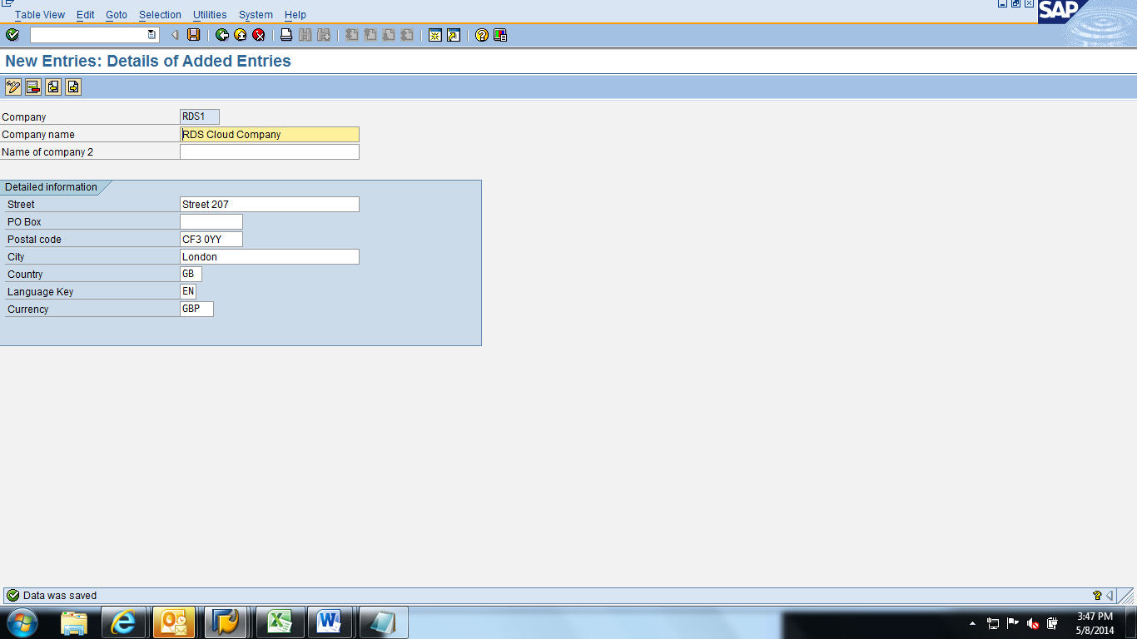

Configure Company code (Transaction Code OX02):

Path: **SAP Customising Implementation Guide > Financial Accounting > Contract Account Receivable and Payable> Organization Units>Set up company codes for Contract Account Receivable and Payable.**

Fill up following fields as shown below:

* company code-ZRD1
* company name- RDS cloud client
* City- London
* Country- GB
* Currency- GBP
* Language- EN

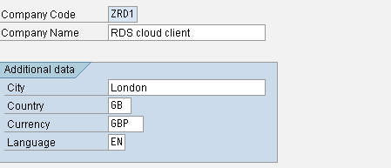

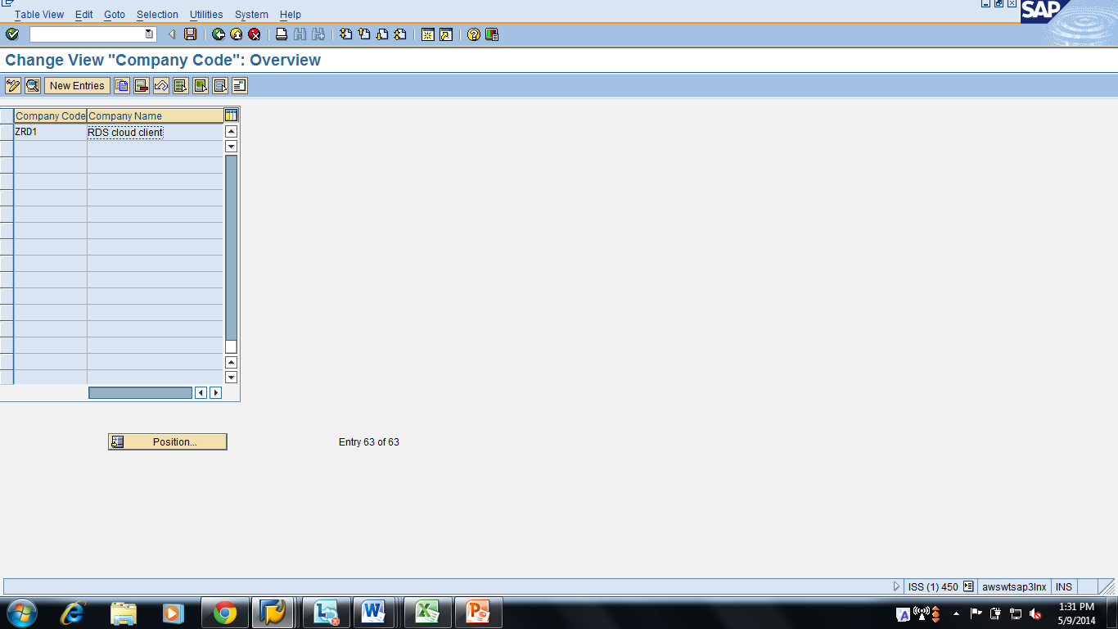

Posting period variant (Transaction Code OBBO):

Path: **SAP Customising Implementation Guide>Financial Accounting>Financial Accounting Global Settings>Document>Posting Periods**

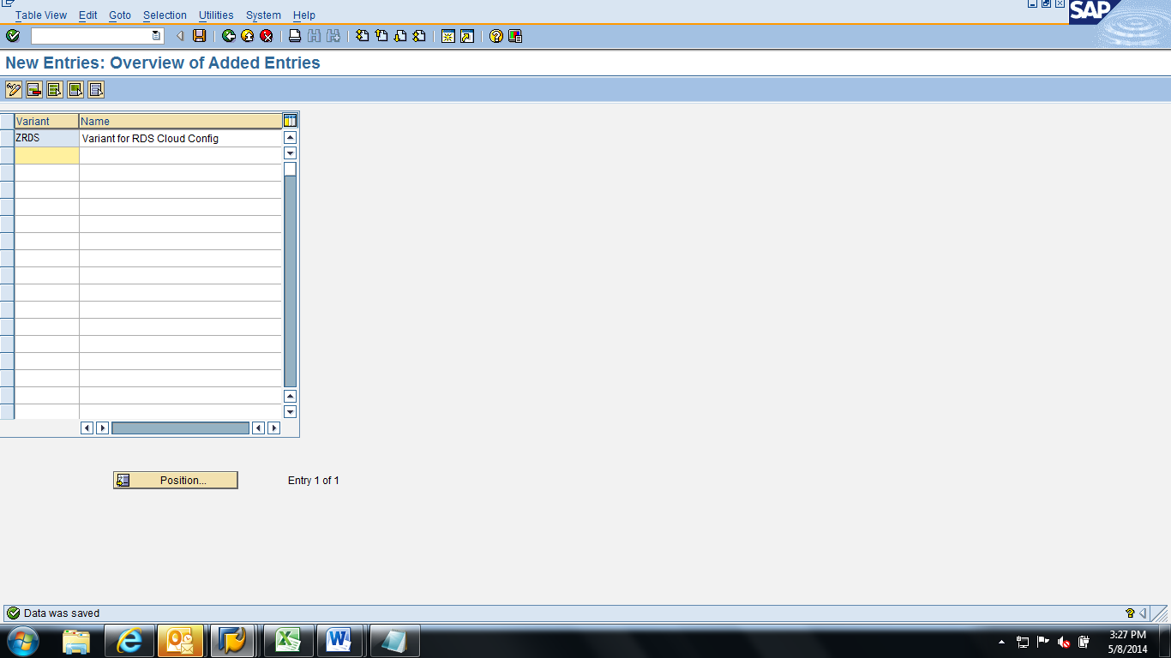

Specify time intervals for posting period variants(Transaction Code OB52):

Path: **SAP Customising Implementation Guide>Financial Accounting>Financial Accounting Global Settings>Document>Posting Periods**

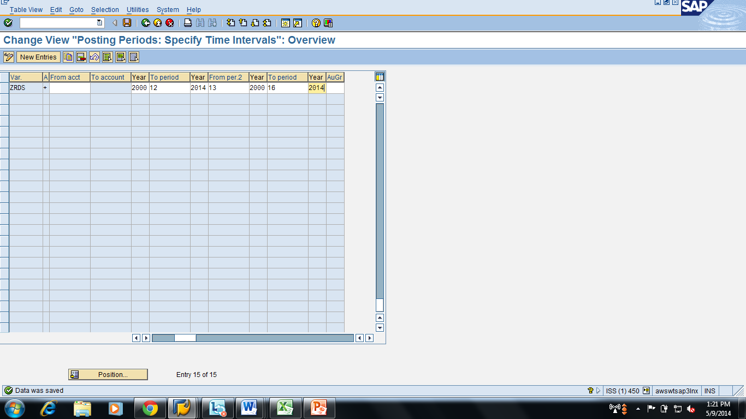

Assign posting variants to company code (Transaction Code OBBP):

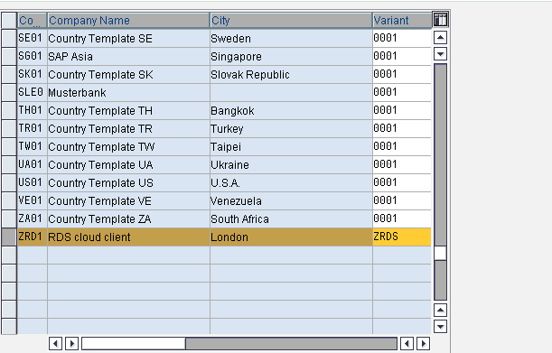

Configure Chart of accounts (Transaction Code OB13):

Path: **SAP Customising Implementation Guide>Financial Accounting>General Ledger Accounting>GL Accounts>Master Records>Preparations>Edit Chart of Accounts List**

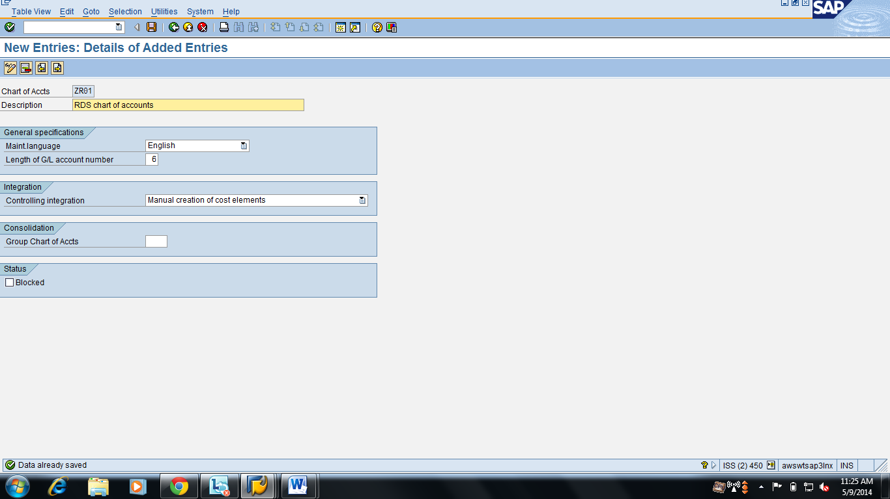

Mapping of chart of accounts to company code (Transaction Code OB62)

Path: Path: **SAP Customising Implementation Guide>Financial Accounting>General Ledger Accounting>GL Accounts>Master Records>Preparations>Assign Company code to Chart of Accounts**

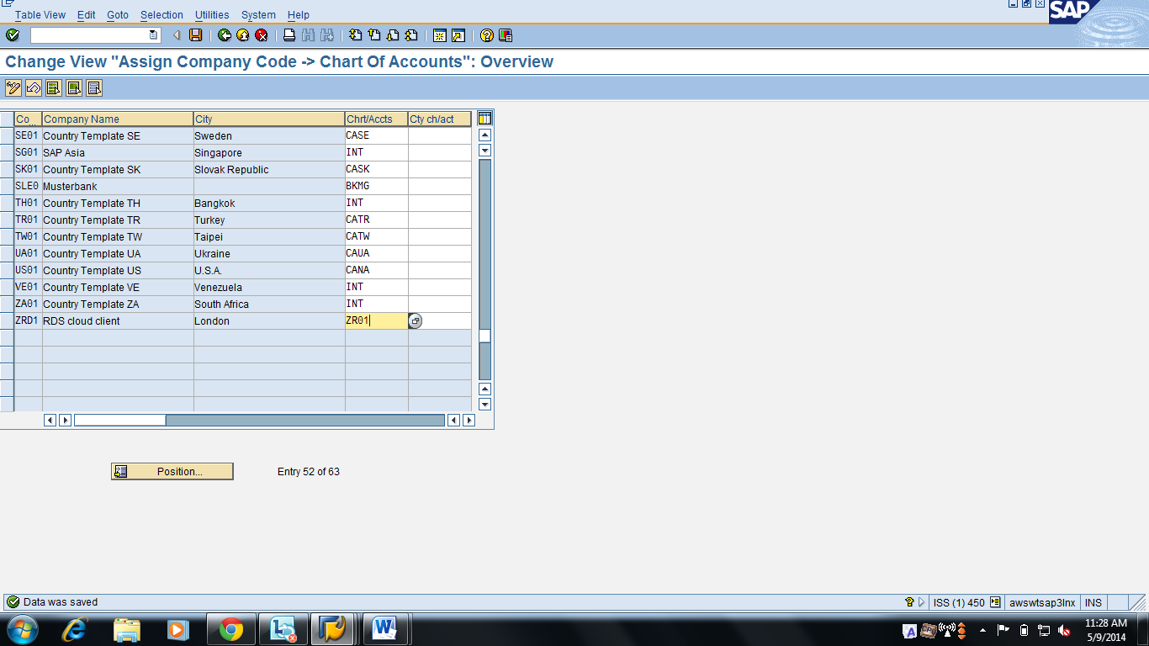

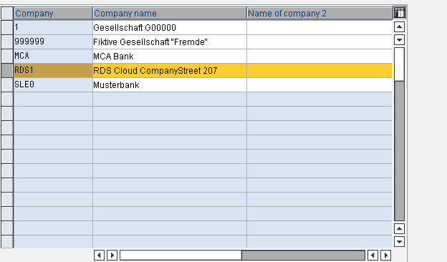

Enter Global parameters for the company code (Transaction Code OBY6):

Path: **SAP Customising Implementation Guide>Financial Accounting>Financial Accounting Global Settings>Company Code>Enter Global Parameters**

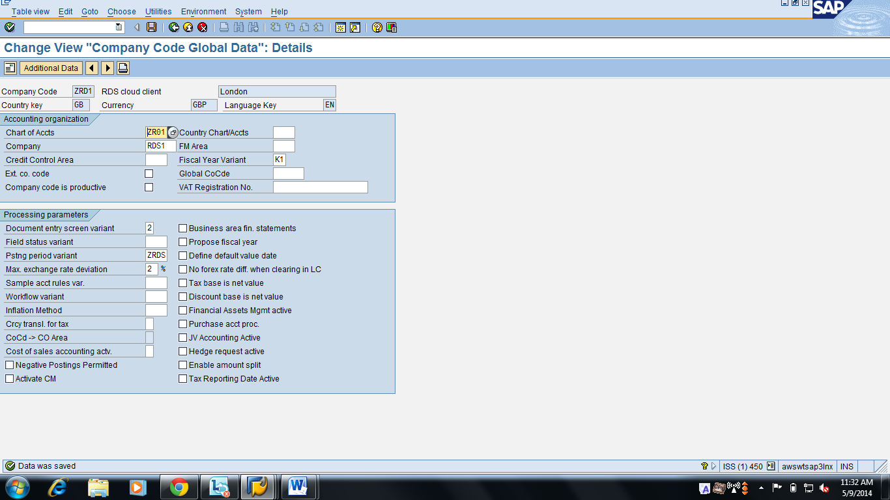

Define tolerance group for GL accounts (Transaction Code OBA0)

Path: **SAP Customising Implementation Guide>Financial Accounting>General Ledger Accounting>Business Transactions>Open Item Clearing>Clearing Differences> Define Tolerance Groups for G/L Accounts**

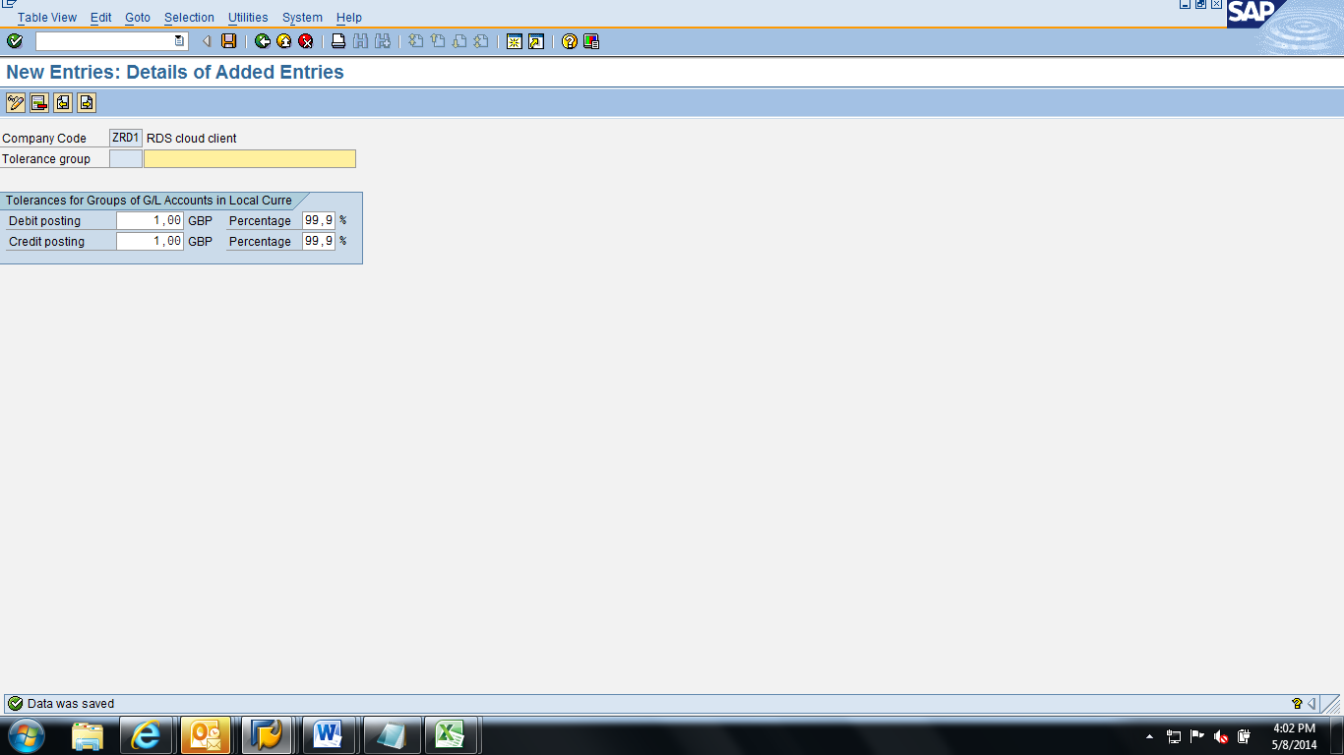

Define validations for posting (Transaction Code OB28):

Path: **SAP Customising Implementation Guide>Financial Accounting>Financial Accounting Global Settings>Document>Line Item> Define Validations for Accounting Documents**

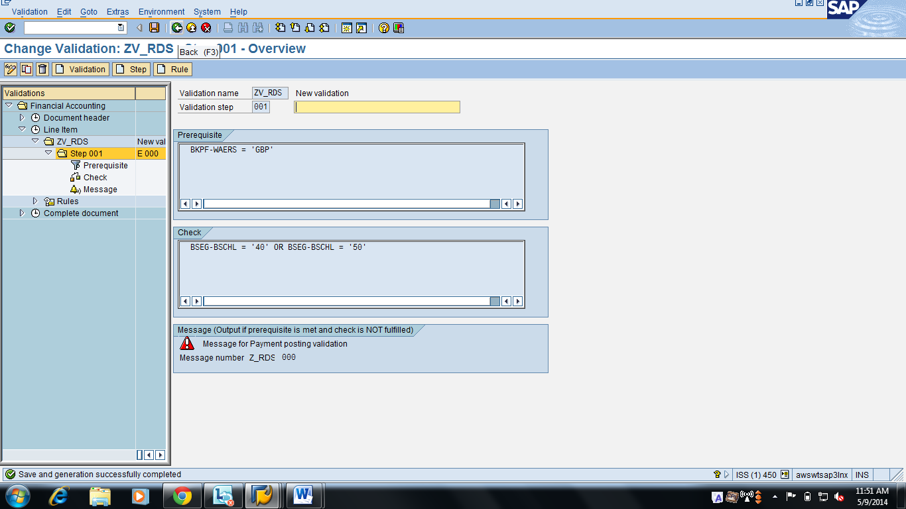

Step10: Maintain controlling area (Transaction Code OX06):

Path: **SAP Customising Implementation Guide/Enterprise Structure/Definition/Controlling/Maintain Controlling Area/ Maintain Controlling Area**

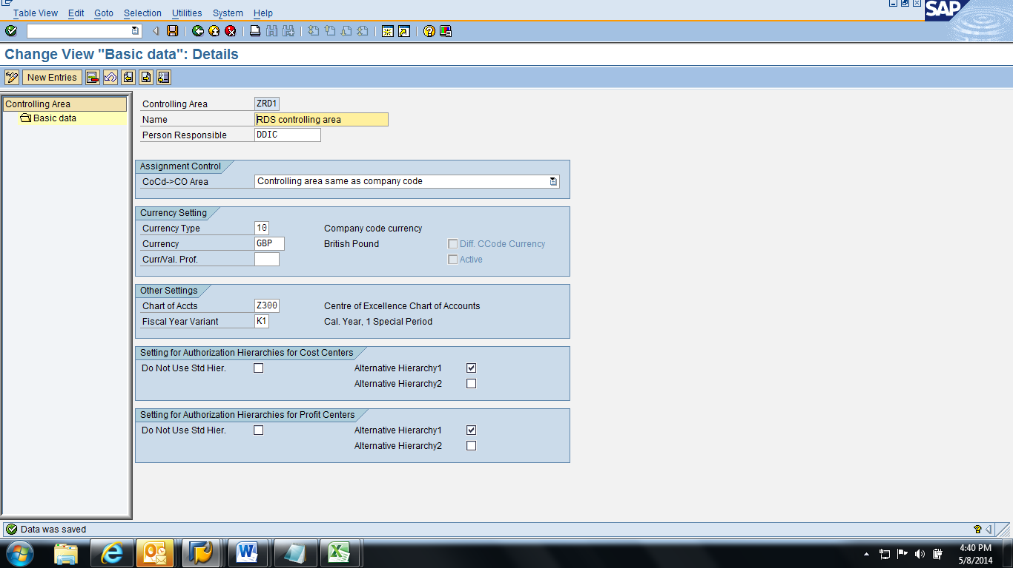

Define Standard Hierarchy (Transaction Code OKEO):

Path: **SAP Customising Implementation Guide>Controlling>Cost Center Accounting>Master Data>Cost Centers>Define Standard Hierarchy**

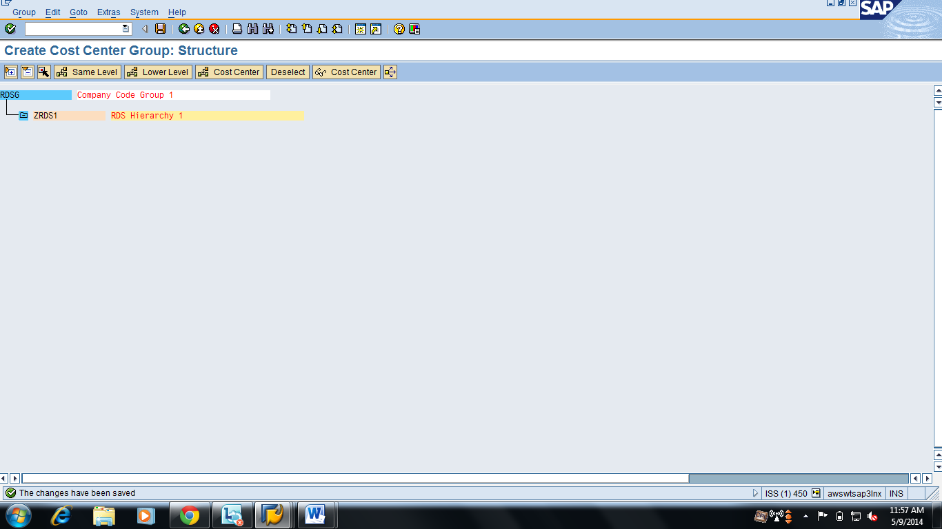

Maintain hierarchy for the controlling area and assign company code to controlling area (Transaction Code OKKP)

Path: **SAP Customising Implementation Guide>Controlling>Cost Center Accounting>Activate Cost Center Accounting in Controlling Area**

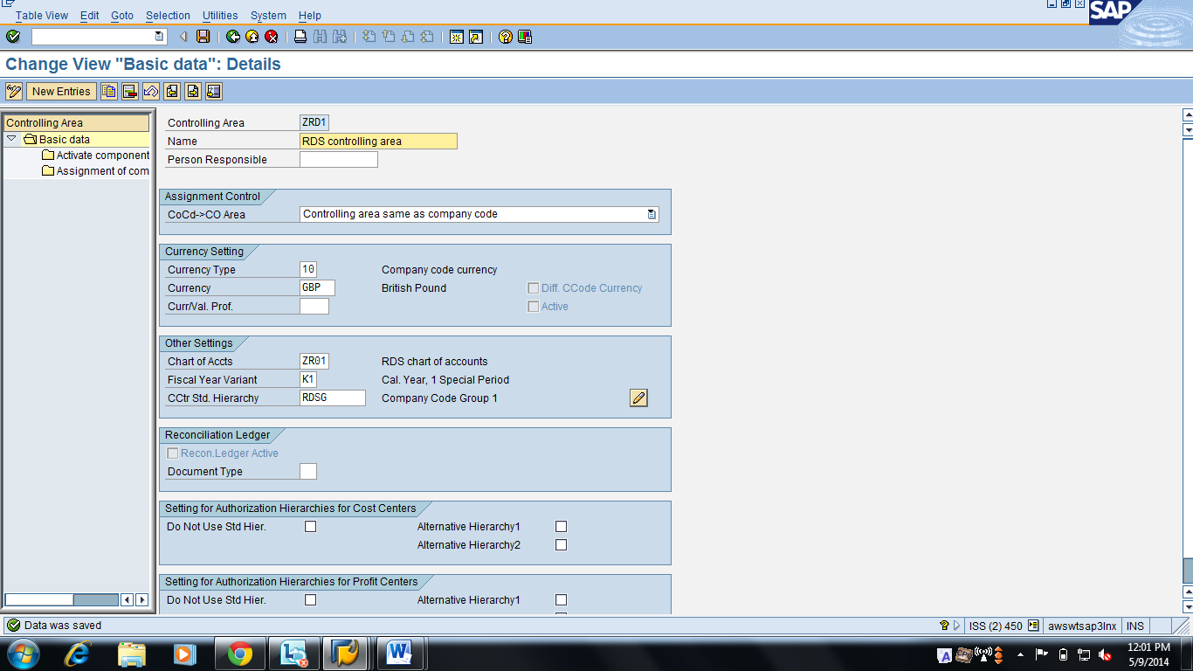

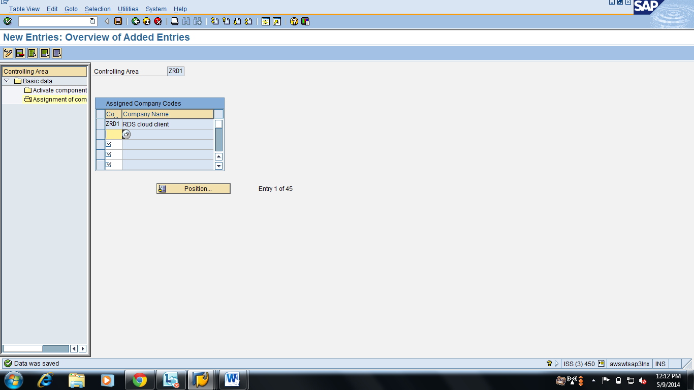

Create Cost center (Transaction Code KS01):

Path: **SAP Customising Implementation Guide>Controlling>Cost Center Accounting> Master Data> Create Cost Centers**

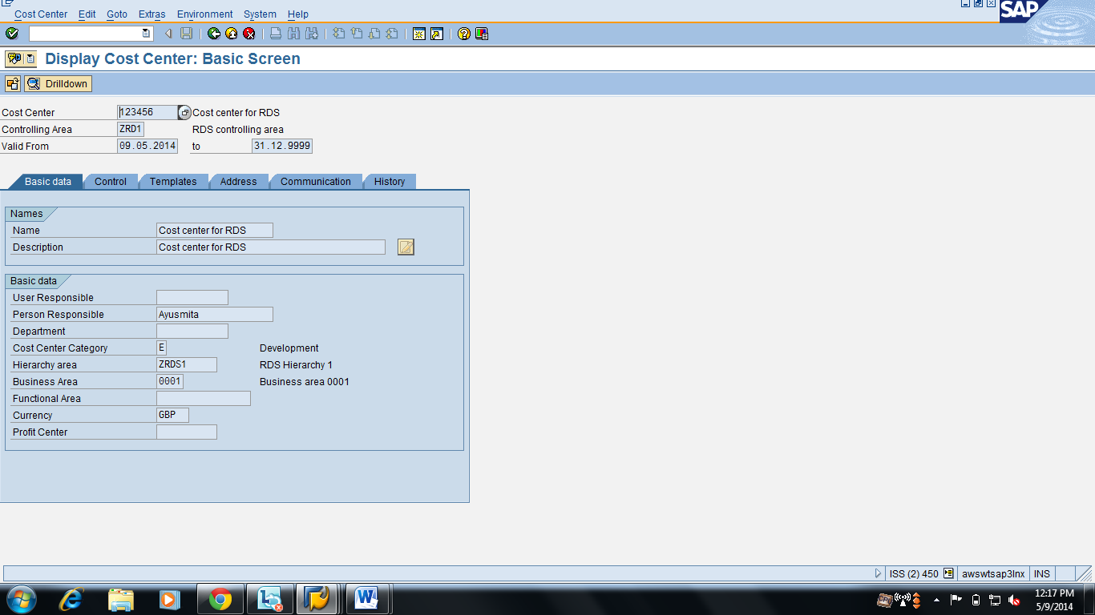

Set Up Company Codes for Contract Accounts Receivable and Payable(Transaction Code SPRO):

**Path: SAP Customizing Implementation Guide>SAP Insurance>Collections>Disbursements>Organizational Units> Setup Company Codes for Contract Accounts Receivable and Payable**

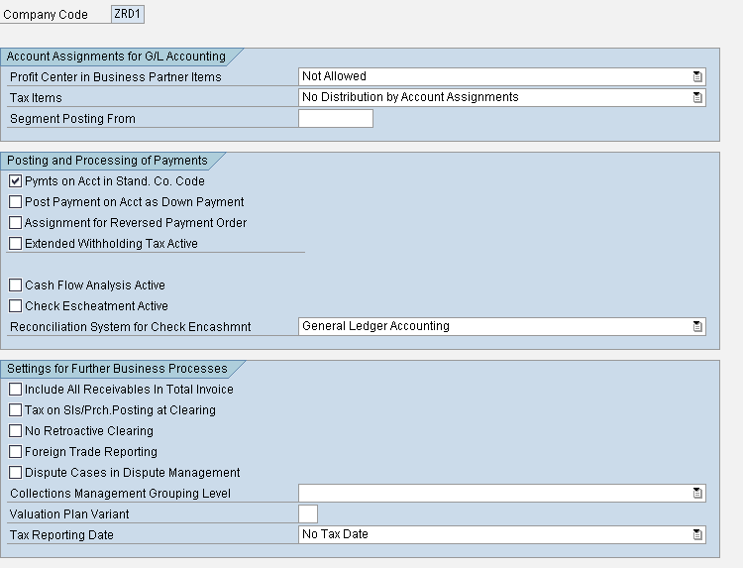

Define Company Code Groups( Transaction Code: SPRO)

Path: **SAP Customizing Implementation Guide>SAP Insurance>Collections>Disbursements>Organizational Units>Define Company Code Groups**

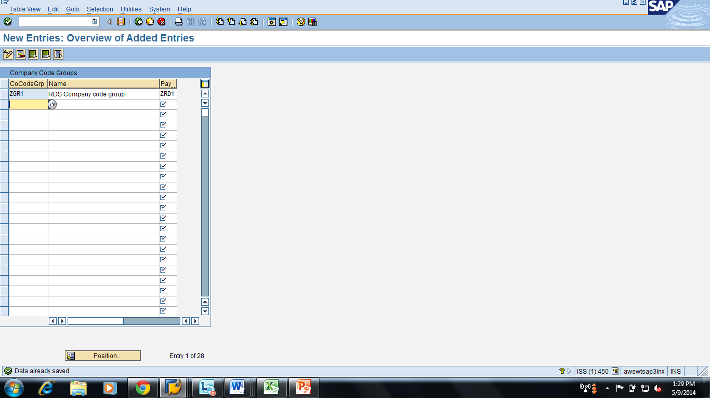

Assign Company Codes to Company Code Groups ( Transaction Code: SPRO)

Path: **SAP Customizing Implementation Guide>SAP Insurance>Collections>Disbursements>Organizational Units>Assign Company Codes to Company Code Groups**

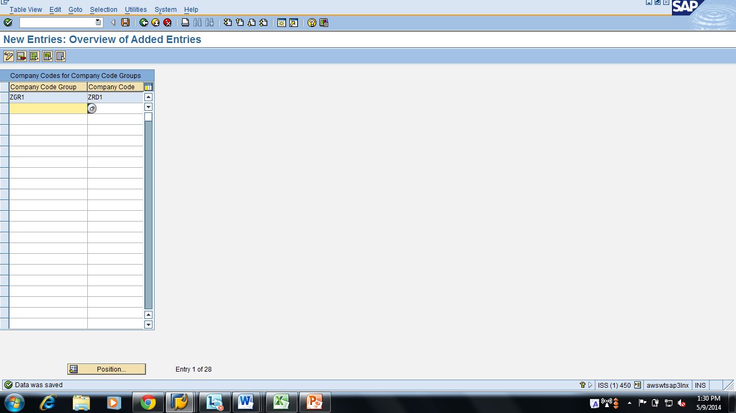

Define CO Account assignment Keys (Transaction Code SPRO):

Path: **SAP Customizing Implementation Guide>SAP Insurance>Collections>Disbursements>Basic Functions>Postings and Document>Document>Define Account Assignments for Automatic Postings> Define CO Account Assignment Keys**

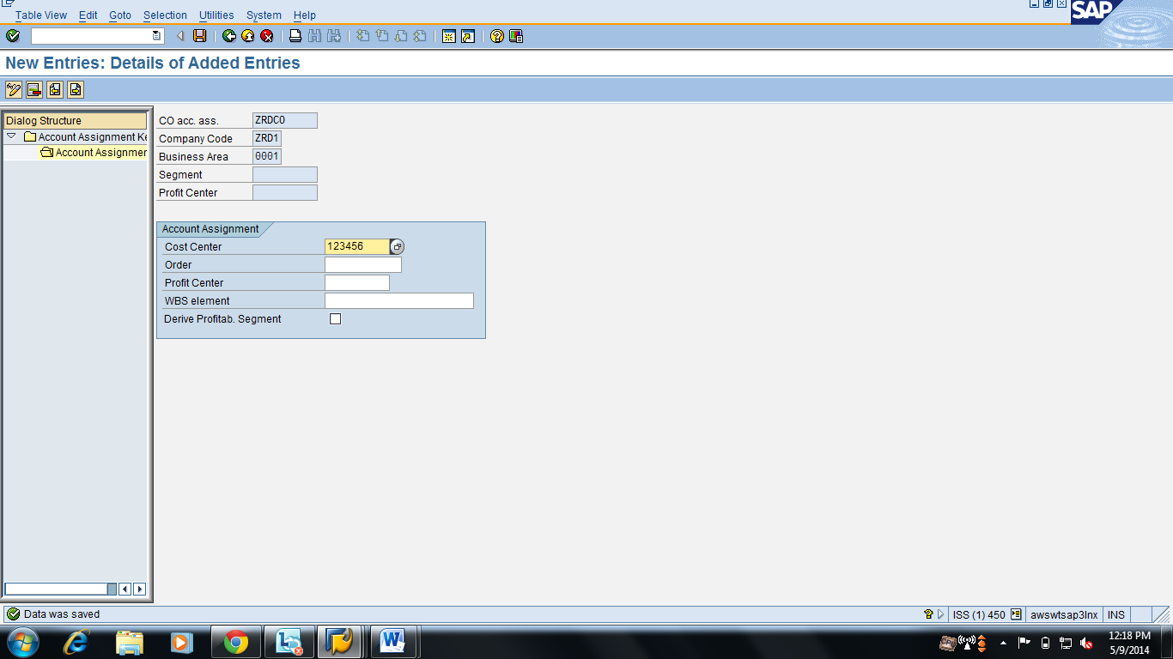

Create application area (Transaction Code: SPRO):

Path: **SAP Customizing Implementation Guide>SAP Insurance>Collections>Disbursements>Basic Functions>Application Area**

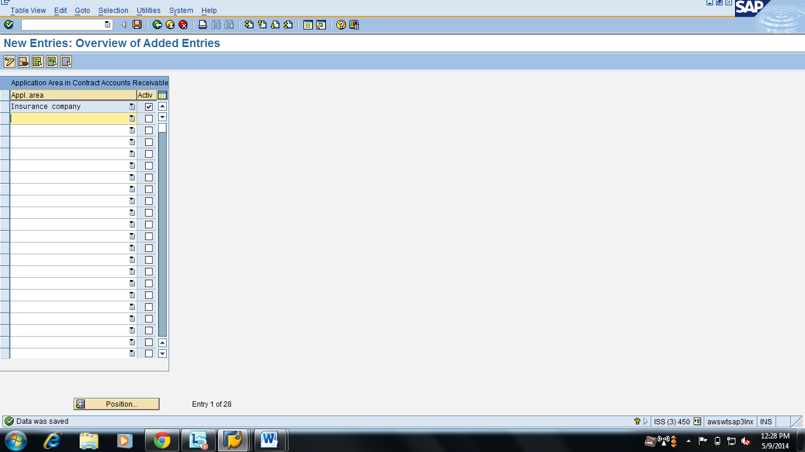

Define Payment method (Transaction Code SPRO):

Path: **SAP Customizing Implementation Guide>SAP Insurance>Collections>Disbursements>Business Transactions>Payments>Incoming>Outgoing Payment Creation>Define Payment Methods**

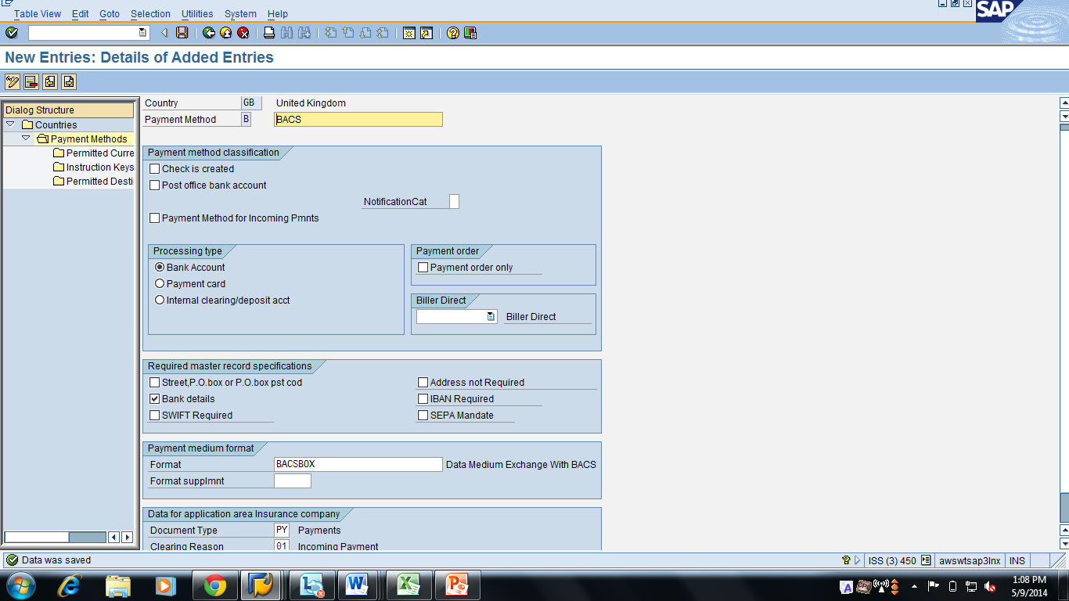

Define specification for paying company code(Transaction Code FQP4):

Path: **SAP Customizing Implementation Guide/SAP Insurance/Collections/Disbursements/Business Transactions/Payments/Incoming/Outgoing Payment Creation/ Define Specification for Paying Company Code**

